Google Classroom on a Computer
- Go to classroom.google.com and click Go to Classroom.
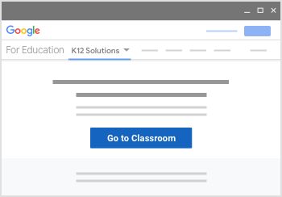
- Enter the email address for your Classroom account and click Next (your email address is made up of your first initial and the first four letters of your surname, followed by ‘ijs-pupils.uk’, e.g. Joe Bloggs would be ‘jblog@ijs-pupils.uk’:
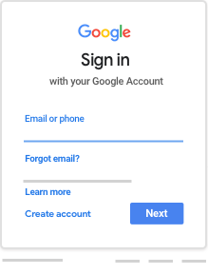
- Enter your password (see covering letter) and click Next.
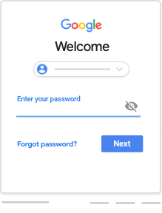

- If there is a welcome message, review it and click Accept.
- Click Get Started.
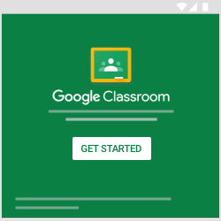
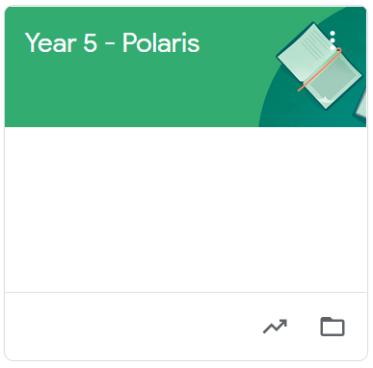
- Click on your class

- Click on ‘Classwork’.
- You can now view your tasks/homework.

